Dashboard:

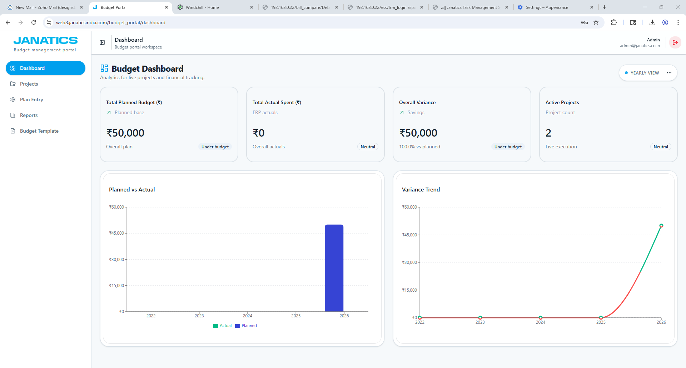

Please make the following fields required:
- Select Year
- Select Period
- Team name

The chart must update based on those selections.

Projects tab :

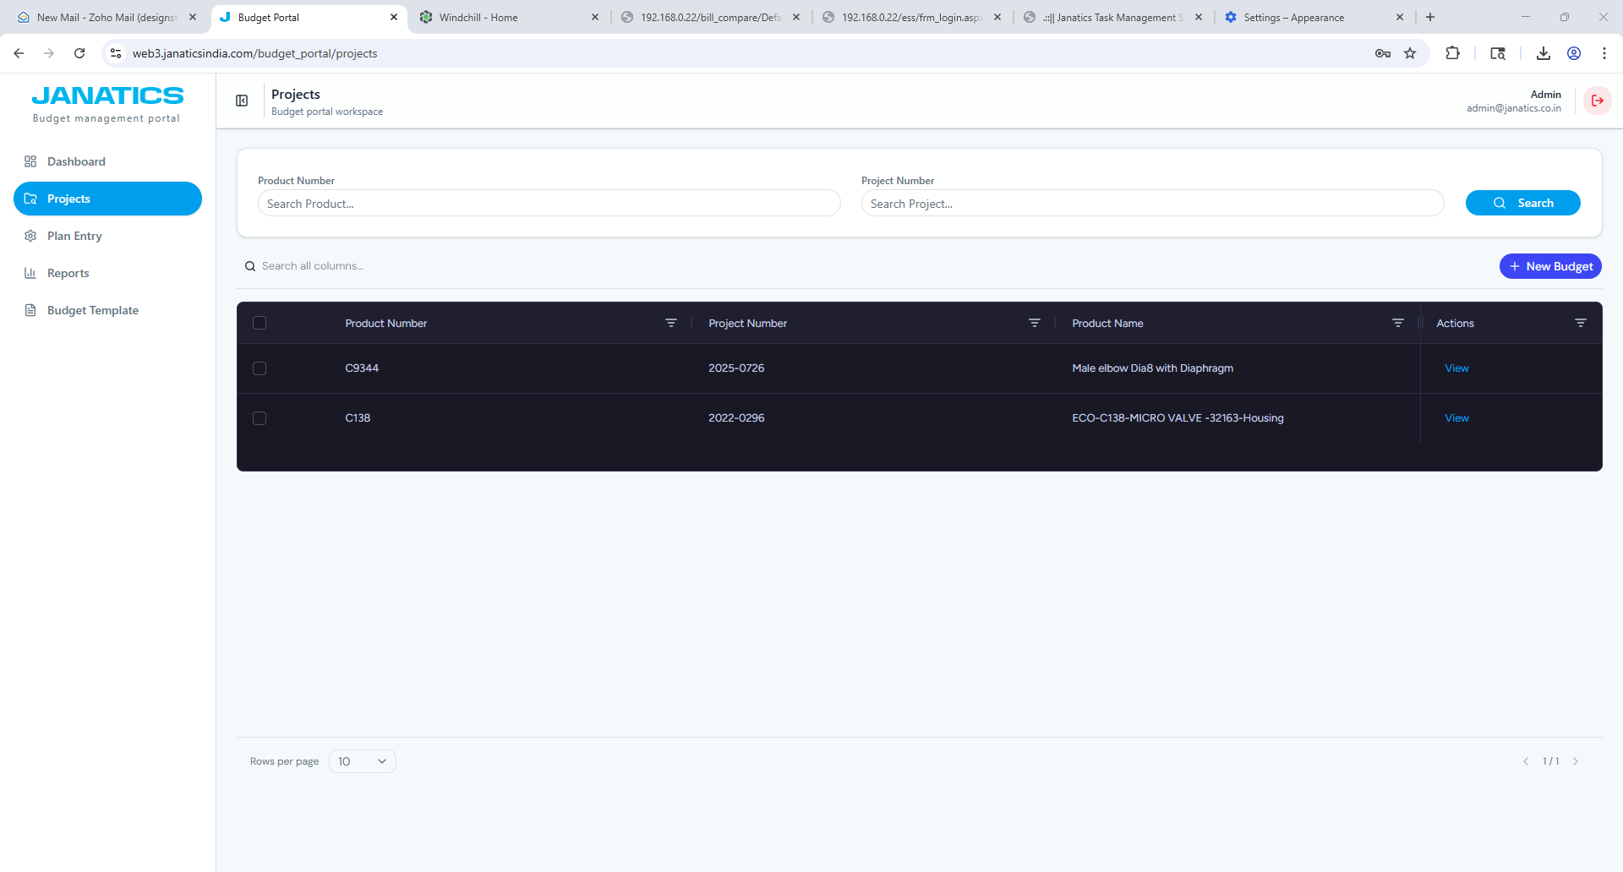
- Project number search is not working.
- Columns to add
- Team name:
NPD Team-1, NPD Team-2, NPD Team-3, NPD Team-4, NPD Team-5, NPD Team-6, NPD Team-7, NPD Team-8
- Product categories:
Cylinder-1, Cylinder-2, Valve, FRL, Fittings
- File Attachment :
File upload field, Allow upload of PDF or word document.
After a signed copy is uploaded and the upload is confirmed, Planned Value field becomes read-only / locked.
- Date :
Budget created date
- Product Name :
- Form: Excel sheet form: headings and footer
Heading: Project cost
Footer sections: Prepared by: & Approved by:
Excel export includes heading and footer on exported template and printed form. (Refer the below form template)
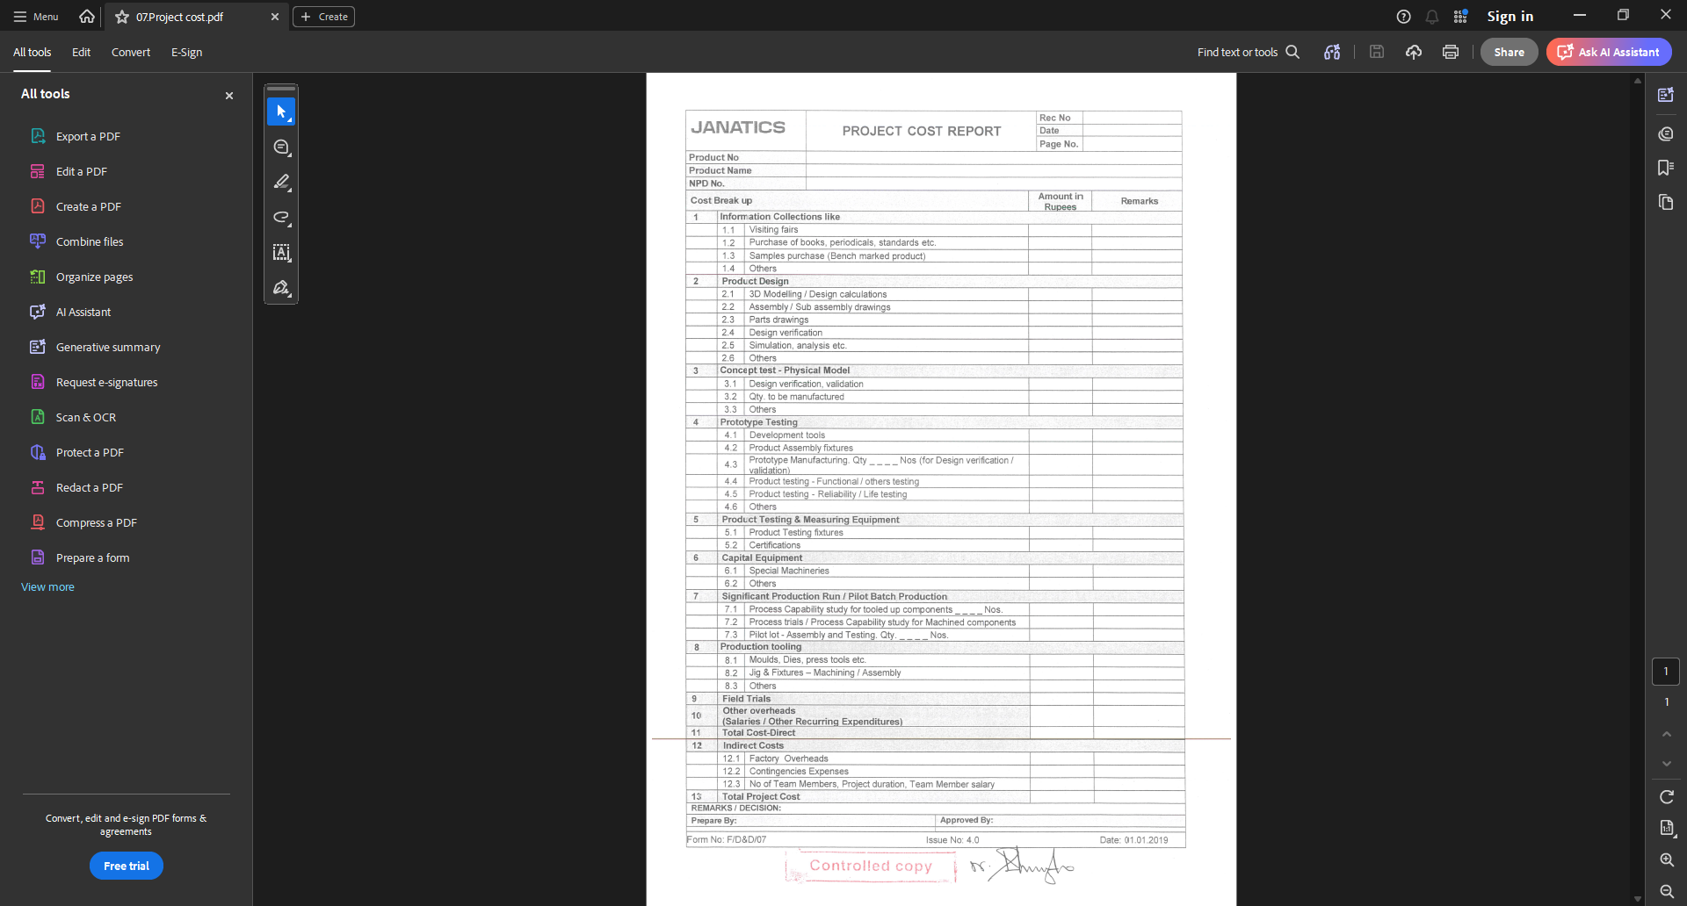

- Required columns on the Projects screen:
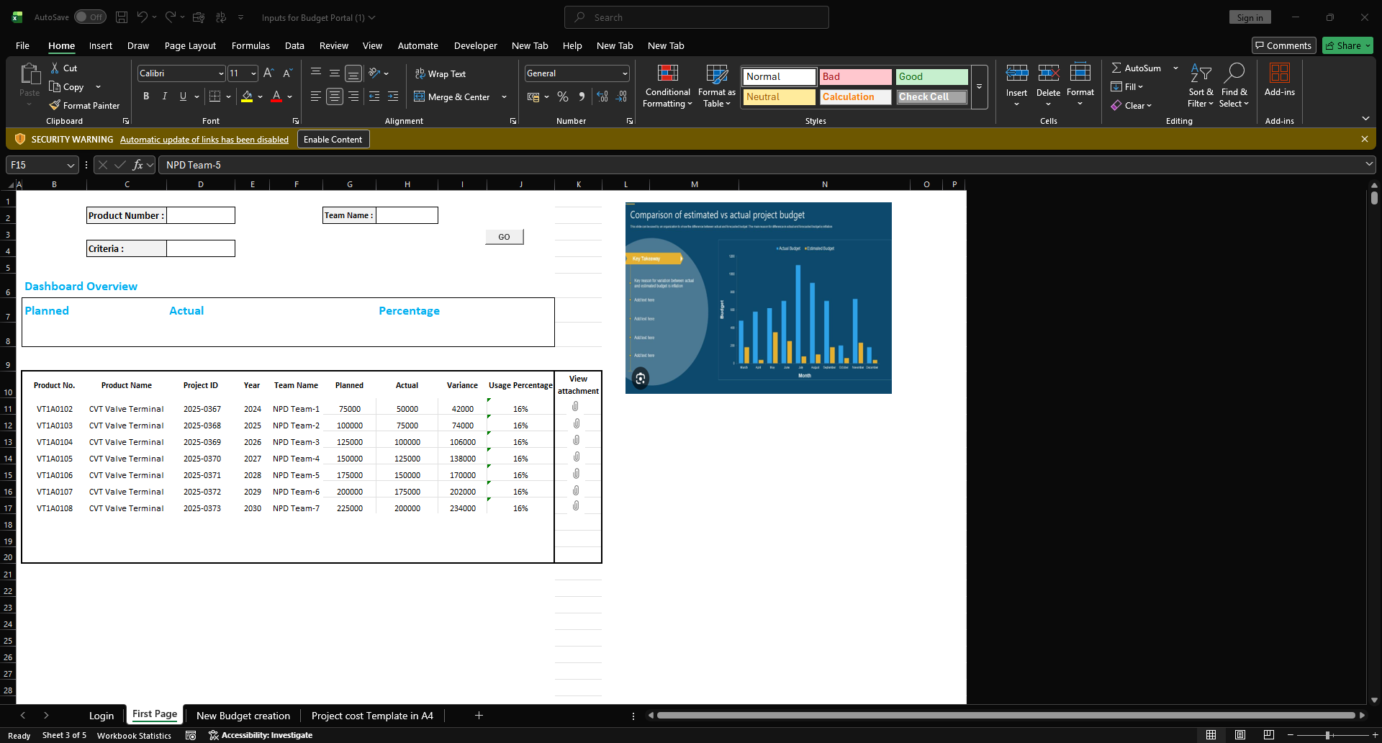
Allow column sorting and filtering (especially on Project Number, Team Name, Product Category, Status, Date ranges).

